Project-1 SQL

CREATE TABLE customers(
customer_id NUMBER,
customer_name VARCHAR2(50)
);

CREATE TABLE stores (
store_id NUMBER,
store_name VARCHAR2(50)
);

CREATE TABLE products (
product_id NUMBER,
category VARCHAR2(50)
);

CREATE TABLE sales(
sale_id NUMBER,
customer_id NUMBER,
store_id NUMBER,
product_id NUMBER,
sale_date DATE,
amount NUMBER,
quantity NUMBER,
discount NUMBER
);

INSERT INTO customers (customer_id, customer_name)
SELECT LEVEL, 'Cust_' || LEVEL
FROM dual
CONNECT BY LEVEL <= 50;

INSERT INTO stores (store_id, store_name) VALUES (1, 'CMR');
INSERT INTO stores (store_id, store_name) VALUES (2, 'SR');
INSERT INTO stores (store_id, store_name) VALUES (3, 'Lucky');

INSERT INTO products (product_id, category) VALUES (1, 'Electronics');
INSERT INTO products (product_id, category) VALUES (2, 'Fashion');
INSERT INTO products (product_id, category) VALUES (3, 'Grocery');
INSERT INTO products (product_id, category) VALUES (4, 'Home');

INSERT INTO sales (
sale_id,
customer_id,
store_id,
product_id,
sale_date,
amount,
quantity,
discount
)
SELECT
LEVEL AS sale_id,
MOD(LEVEL, 50) + 1 AS customer_id,
MOD(LEVEL, 3) + 1 AS store_id,
MOD(LEVEL, 4) + 1 AS product_id,
DATE '2025-01-01' + MOD(LEVEL, 90) AS sale_date,
ROUND(DBMS_RANDOM.VALUE(100, 10000)) AS amount,
MOD(LEVEL, 5) + 1 AS quantity,
CASE
WHEN MOD(LEVEL, 4) = 0 THEN NULL
ELSE ROUND(DBMS_RANDOM.VALUE(10, 500))
END AS discount
FROM dual
CONNECT BY LEVEL <= 1000;

COMMIT;

SELECT * FROM customers;
SELECT * FROM stores;
SELECT * FROM products;
SELECT * FROM sales;

1. Data Understanding
--1. find total number of transactions
select count(*) as total_transactions
from sales;
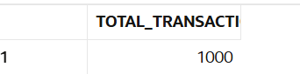

--2. find total revenue generated
select sum(amount) as total_revenue
from sales;
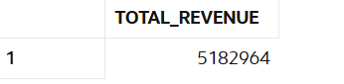

--3. find total unique customers
select count(distinct customer_id) as unique_customers
from sales;
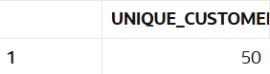

--4. find average order value
select avg(amount) as average_order_value
from sales;
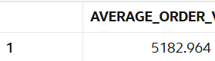

--5. find total quantity sold
select sum(quantity) as total_quantity_sold
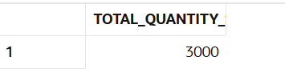
from sales;

--6. find minimum and maximum sale amount
select min(amount) as min_sale_amount,
max(amount) as max_sale_amount
from sales;
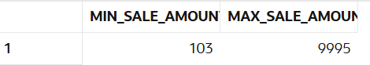

--7. find average discount given
select avg(discount) as average_discount
from sales;
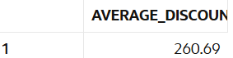

--8. find total sales per store
select store_id, sum(amount) as total_sales
from sales
group by store_id;
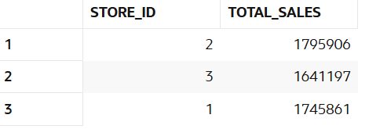

--9. find total sales per category
select p.category, sum(s.amount) as total_sales
from sales s
join products p on s.product_id = p.product_id
group by p.category;
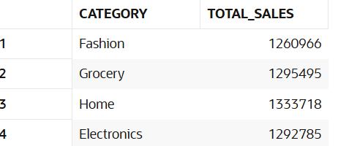

--10. find number of transactions per day
select sale_date, count(*) as transactions
from sales
group by sale_date
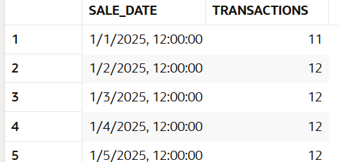
order by sale_date;

2. Data Cleaning
Manager Requirement:
Data looks inconsistent, fix NULL issues before analysis.
-- 11. replace null discount with 0
select sale_id,
nvl(discount,0) as discount
from sales;
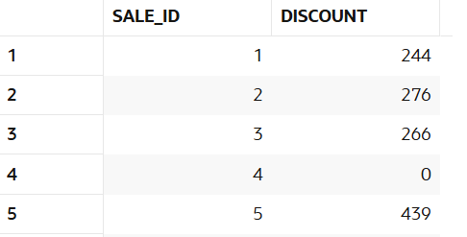

-- 12. find number of null discounts
select count(*) as null_discounts
from sales
where discount is null;
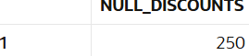

-- 13. calculate net revenue (amount - discount)
select sale_id,
amount - nvl(discount,0) as net_revenue
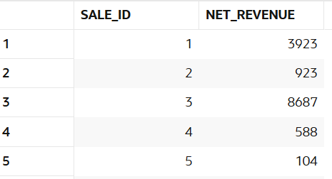
from sales;

-- 14. replace null quantity with 1
select sale_id,
nvl(quantity,1) as quantity
from sales;
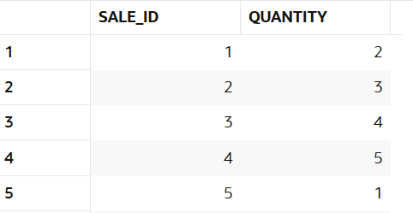

-- 15. identify rows where amount is null
select *
from sales
where amount is null;

-- 16. use coalesce to handle multiple null columns
select sale_id,
coalesce(discount,0) as discount_value
from sales;
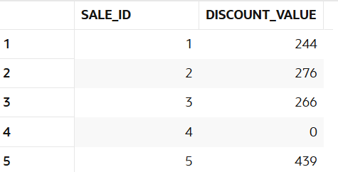

-- 17. create a cleaned column for revenue
select sale_id,amount,nvl(discount,0) as discount,amount - nvl(discount,0) as revenue
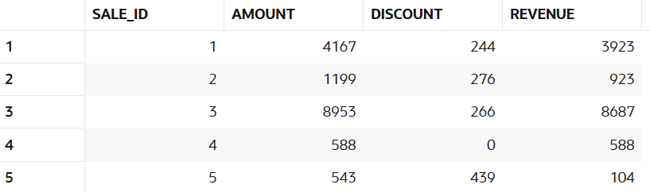
from sales;
-- 18. check percentage of missing discount data
select (count(case when discount is null then 1 end) * 100) / count(*) as missing_discount_percentage
from sales;
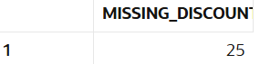

-- 19. flag rows with missing values
select sale_id,discount
case
when discount is null then 'missing_discount'
else 'complete'
end as data_status
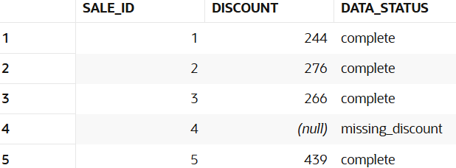
from sales;

3. Filtering (WHERE)
Manager Requirement:
I want specific insights based on conditions.
-- 21. find sales in the last 30 days
select * from sales_clean
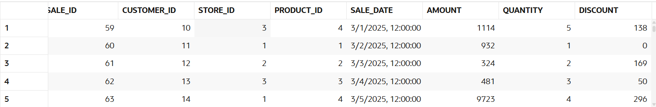
where sale_date >= (select max(sale_date) from sales) - 30;

-- 22. find sales above 5000
select * from sales_clean
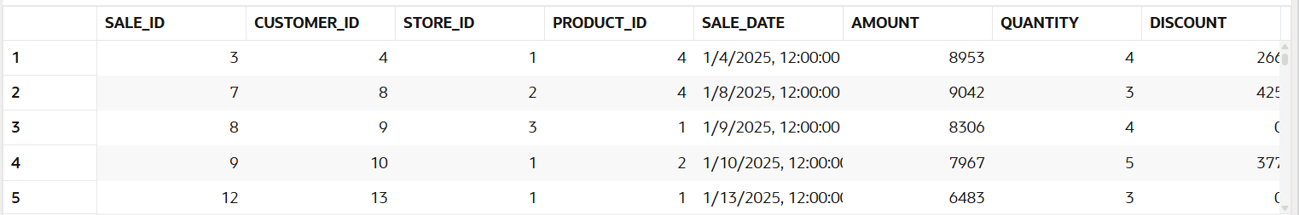
where amount > 5000;

-- 23. find sales between 1000 and 5000
select * from sales_clean
where amount between 1000 and 5000;

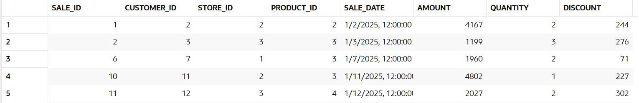
-- 24. find sales from cmr store
select * from sales_clean
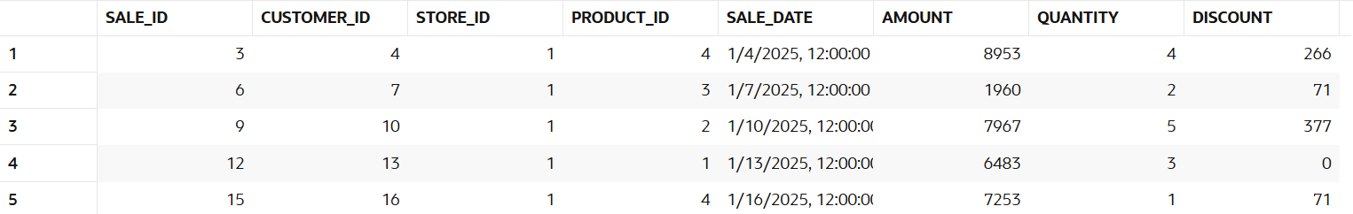
where store_id = 1;
-- 25. find electronics category sales
select s.* from sales_clean s
join products p on s.product_id = p.product_id
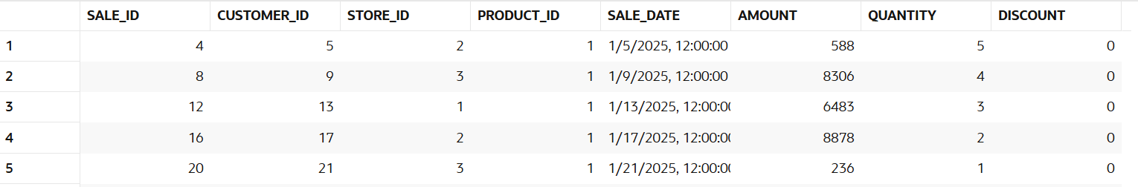
where p.category = 'Electronics';

-- 26. find sales excluding grocery category
select s.* from sales_clean s
join products p on s.product_id = p.product_id
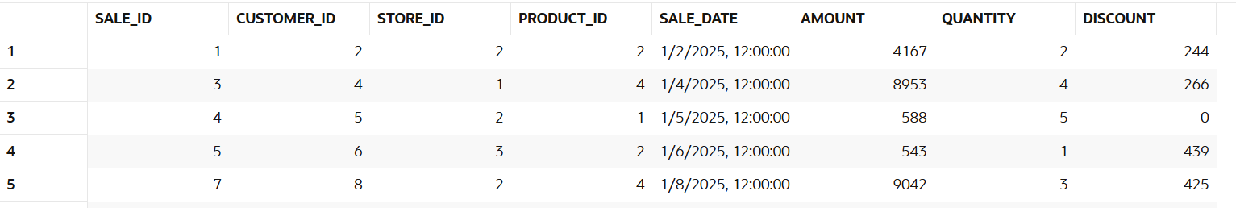
where p.category <> 'Grocery';

-- 27. find customers from specific store
select distinct customer_id from sales_clean
where store_id = 1;
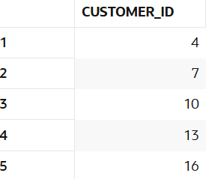

-- 28. find high discount transactions
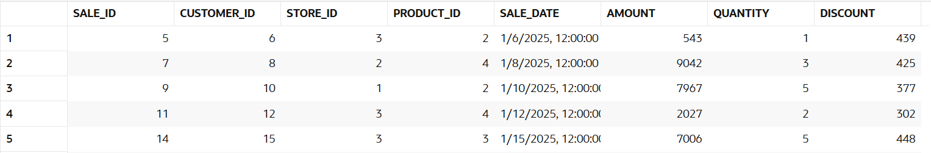
select * from sales_clean where discount > 300;
-- 29. find low quantity sales
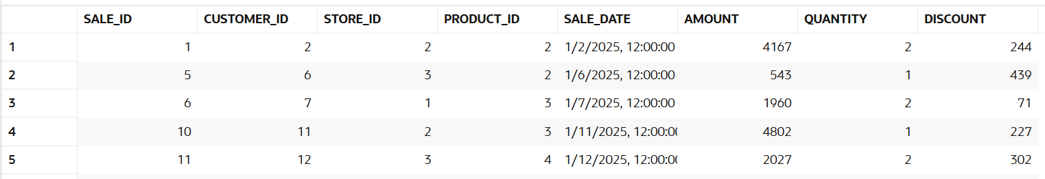
select * from sales_clean where quantity <= 2;

-- 30. find recent transactions
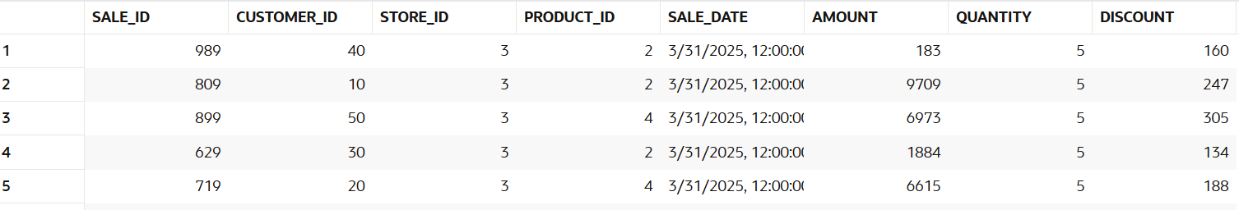
select * from sales_clean order by sale_date desc;

4. Aggregation (GROUP BY)
Manager Requirement:
Break down performance across business segments.
-- 31. revenue per store
select store_id, sum(amount) as revenue
from sales_clean
group by store_id;
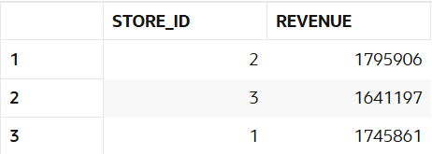

-- 32. revenue per category
select p.category, sum(s.amount) as revenue
from sales_clean s
join products p on s.product_id = p.product_id
group by p.category;
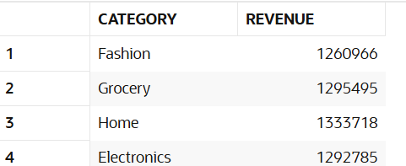

-- 33. revenue per customer
select customer_id, sum(amount) as revenue
from sales_clean
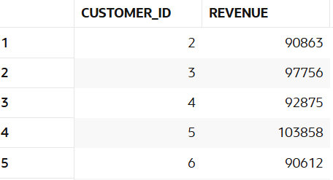
group by customer_id;

-- 34. monthly revenue
select to_char(sale_date,'yyyy-mm') as month, sum(amount) as revenue
from sales_clean
group by to_char(sale_date,'yyyy-mm')
order by month;
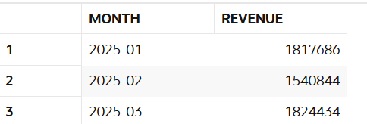

-- 35. daily revenue
select sale_date, sum(amount) as revenue
from sales_clean
group by sale_date
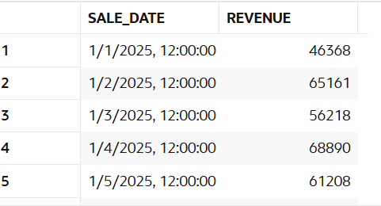
order by sale_date;

-- 36. average sales per store
select store_id, avg(amount) as avg_sales
from sales_clean
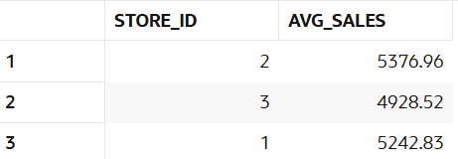
group by store_id;

-- 37. total quantity per category
select p.category, sum(s.quantity) as total_quantity
from sales_clean s
join products p on s.product_id = p.product_id
group by p.category;
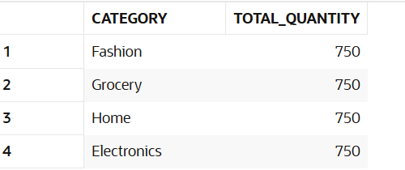

-- 38. total discount per store
select store_id, sum(discount) as total_discount
from sales_clean
group by store_id;
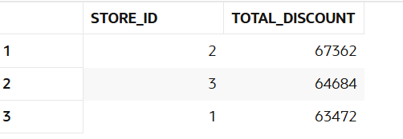

-- 39. customer-wise total spending
select customer_id, sum(amount) as total_spending
from sales_clean
group by customer_id;
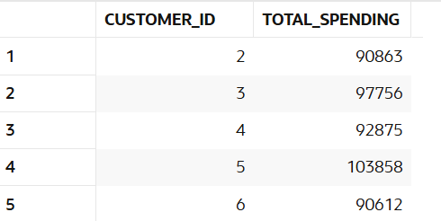

-- 40. store-wise transaction count
select store_id, count(*) as transaction_count
from sales_clean
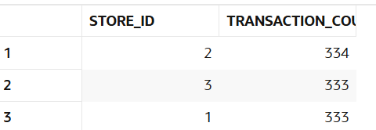
group by store_id

5. HAVING
Manager Requirement:
Find top performing segments.
-- 41. customers with revenue > 20000
select customer_id, sum(amount) as revenue
from sales_clean
group by customer_id
having sum(amount) > 20000;
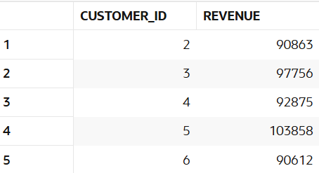

-- 42. stores with revenue > 100000
select store_id, sum(amount) as revenue
from sales_clean
group by store_id
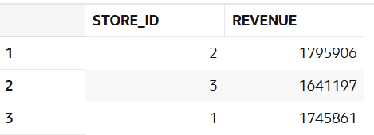
having sum(amount) > 100000;

-- 43. categories with average sales > 3000
select p.category, avg(s.amount) as avg_sales
from sales_clean s
join products p on s.product_id = p.product_id
group by p.category
having avg(s.amount) > 3000;
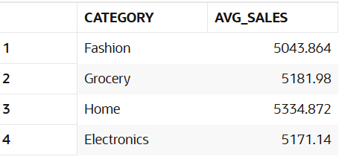

-- 44. customers with more than 5 transactions
select customer_id, count(*) as transactions
from sales_clean
group by customer_id
having count(*) > 5;
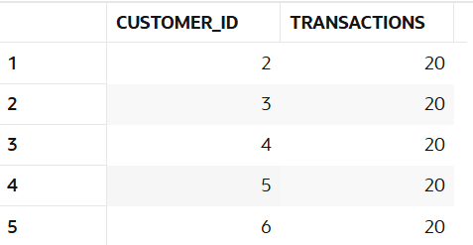

-- 45. stores with high discount usage
select store_id, sum(discount) as total_discount
from sales_clean
group by store_id
having sum(discount) > 5000;
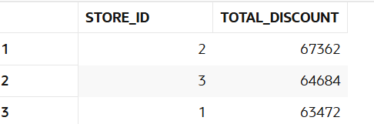

-- 46. categories with low performance
select p.category, sum(s.amount) as revenue
from sales_clean s
join products p on s.product_id = p.product_id
group by p.category
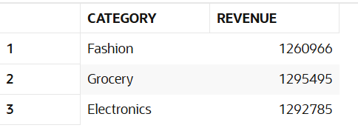
having sum(s.amount) < 1200000;

-- 47. customers with high average order value
select customer_id, avg(amount) as avg_order_value
from sales_clean
group by customer_id
having avg(amount) > 4000;
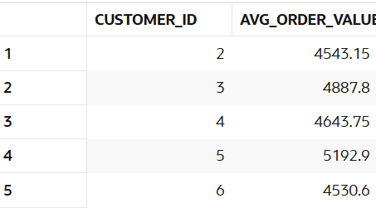

-- 48. find top customers using having
select customer_id, sum(amount) as revenue
from sales_clean
group by customer_id
having sum(amount) > 30000;
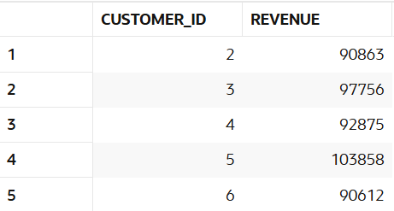

-- 49. stores with maximum transactions
select store_id, count(*) as transactions
from sales_clean
group by store_id
having count(*) = (
select max(cnt)
from (
select count(*) as cnt
from sales_clean
group by store_id
)
);
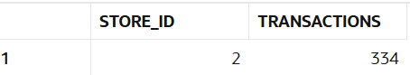

-- 50. categories with high growth
select p.category, sum(s.amount) as revenue
from sales_clean s
join products p on s.product_id = p.product_id
group by p.category
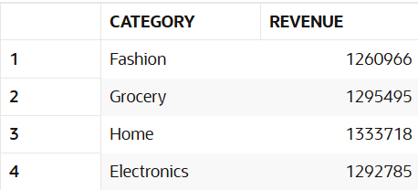
having sum(s.amount) > 600000;

6. CASE WHEN
Manager Requirement:
Segment customers for business decisions.
-- 51. classify customers as high medium low spenders
select customer_id, sum(amount) as revenue,
case when sum(amount) > 100000 then 'high spender'
when sum(amount) between 80000 and 90000 then 'medium spender'
else 'low spender'
end as customer_segment
from sales_clean
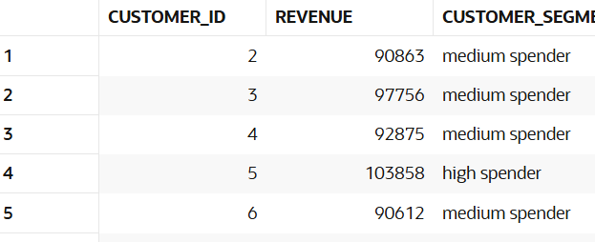
group by customer_id;

-- 52. classify transactions as big or small
select sale_id, amount,
case when amount > 5000 then 'big sale'
else 'small sale'
end as transaction_type
from sales_clean;
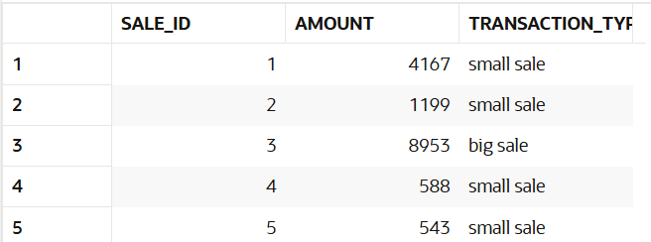

-- 53. create discount flag
select sale_id, discount,
case when discount > 0 then 'discount applied'
else 'no discount'
end as discount_flag
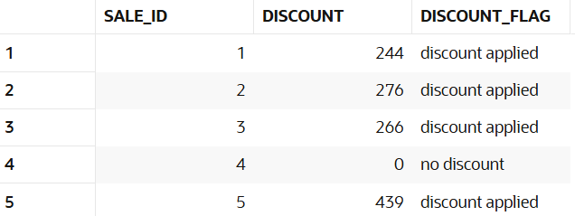
from sales_clean;

-- 54. segment stores based on revenue
select store_id, sum(amount) as revenue,
case when sum(amount) > 1000000 then 'top store'
when sum(amount) between 500000 and 1000000 then 'average store'
else 'low store'
end as store_segment
from sales_clean
group by store_id;
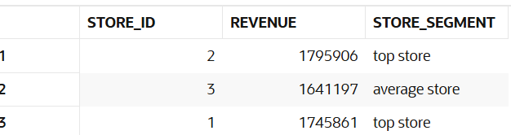

-- 55. categorize customers based on frequency
select customer_id, count(*) as transactions,
case when count(*) > 30 then 'frequent'
when count(*) between 15 and 30 then 'regular'
else 'occasional'
end as customer_frequency
from sales_clean
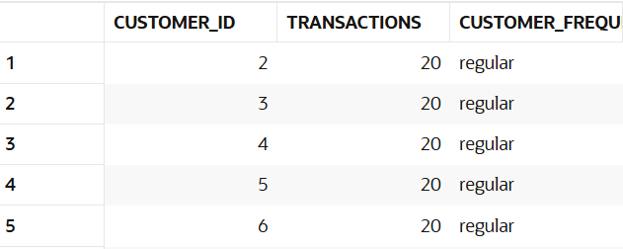
group by customer_id;

-- 56. create sales buckets
select sale_id, amount,
case when amount < 1000 then 'low'
when amount between 1000 and 5000 then 'medium'
else 'high'
end as sales_bucket
from sales_clean;
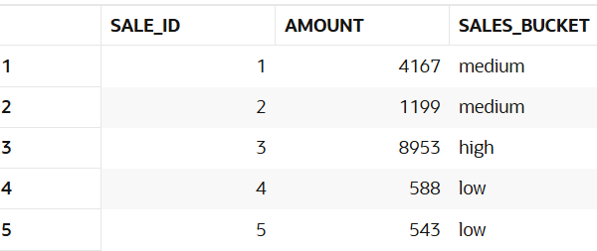

-- 57. identify premium customers
select customer_id, sum(amount) as revenue,
case when sum(amount) > 100000 then 'premium'
else 'normal'
end as customer_type
from sales_clean
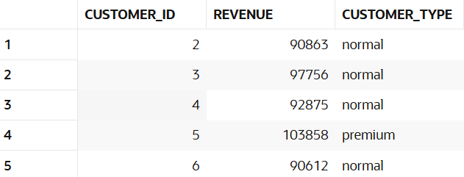
group by customer_id;

-- 58. mark high value transactions
select sale_id, amount,
case when amount > 7000 then 'high value'
else 'normal'
end as transaction_value
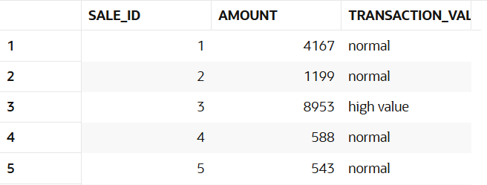
from sales_clean;

-- 59. classify categories based on performance
select p.category, sum(s.amount) as revenue,
case when sum(s.amount) > 700000 then 'top category'
when sum(s.amount) between 300000 and 700000 then 'average category'
else 'low category'
end as category_performance
from sales_clean s join products p on s.product_id = p.product_id
group by p.category;
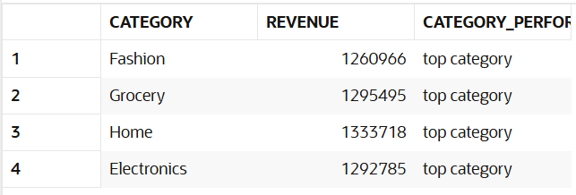

-- 60. create custom labels for reporting
select sale_id, store_id,
case when store_id = 1 then 'cmr store'
when store_id = 2 then 'sr store'
when store_id = 3 then 'lucky store'
end as store_label
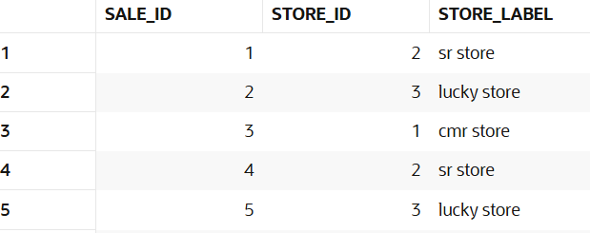
from sales_clean;

-- 61. Find total revenue by store name
select st.store_name, sum(s.amount) as revenue
from sales s
join stores st on s.store_id = st.store_id
group by st.store_name
order by revenue desc;
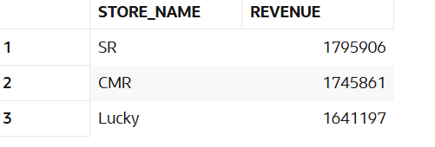

-- 62. Find total quantity sold by store name
select st.store_name, sum(s.quantity) as total_quantity
from sales s
join stores st on s.store_id = st.store_id
group by st.store_name
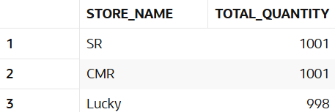
order by total_quantity desc;

-- 63. Find number of transactions by store
select st.store_name, count(s.sale_id) as transactions
from sales s
join stores st on s.store_id = st.store_id
group by st.store_name
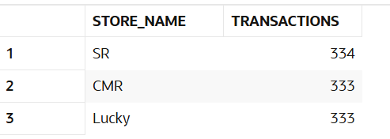
order by transactions desc;

-- 64. Find total revenue by product category
select p.category, sum(s.amount) as revenue
from sales s
join products p on s.product_id = p.product_id
group by p.category
order by revenue desc;

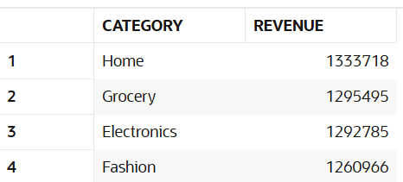

-- 65. Find total quantity sold by product category
select p.category, sum(s.quantity) as total_quantity
from sales s
join products p on s.product_id = p.product_id
group by p.category
order by total_quantity desc;
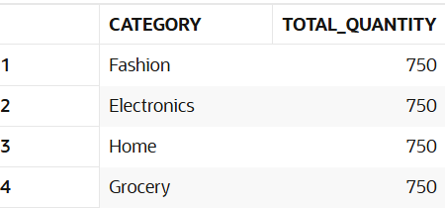

-- 66. Find number of transactions by product category
select p.category, count(s.sale_id) as transactions
from sales s
join products p on s.product_id = p.product_id
group by p.category
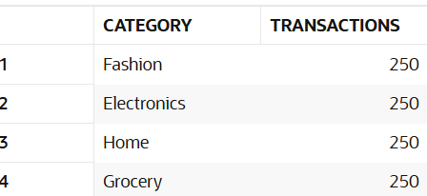
order by transactions desc;

-- 67. Find total revenue by customer name
select c.customer_name, sum(s.amount) as revenue
from sales s
join customers c on s.customer_id = c.customer_id
group by c.customer_name
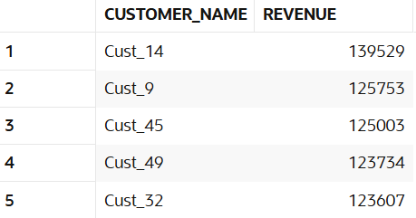
order by revenue desc;

-- 68. Find total quantity purchased by each customer
select c.customer_name, sum(s.quantity) as total_quantity
from sales s
join customers c on s.customer_id = c.customer_id
group by c.customer_name
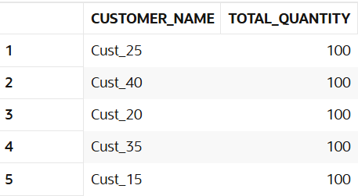
order by total_quantity desc;

-- 69. Find number of purchases by each customer
select c.customer_name, count(s.sale_id) as purchases
from sales s
join customers c on s.customer_id = c.customer_id
group by c.customer_name
order by purchases desc;
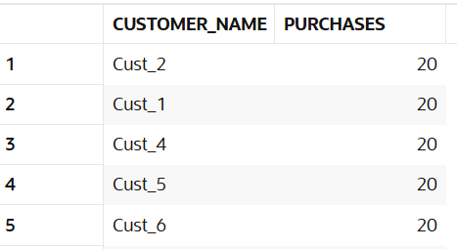

-- 70. Find average revenue per customer
select c.customer_name, avg(s.amount) as avg_revenue
from sales s
join customers c on s.customer_id = c.customer_id
group by c.customer_name
order by avg_revenue desc;
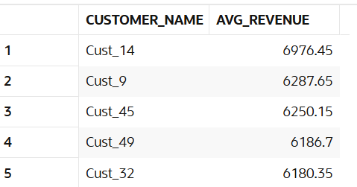

-- 71. Find total revenue per store and product category
select st.store_name, p.category, sum(s.amount) as revenue
from sales s
join stores st on s.store_id = st.store_id
join products p on s.product_id = p.product_id
group by st.store_name, p.category
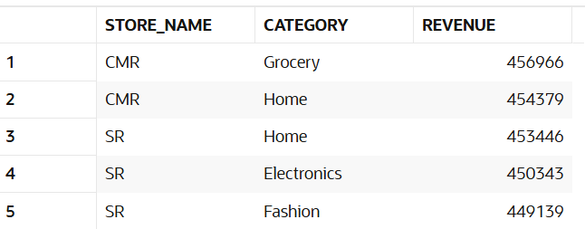
order by revenue desc;

-- 72. Find total quantity sold per store and product category
select st.store_name, p.category, sum(s.quantity) as total_quantity
from sales s
join stores st on s.store_id = st.store_id
join products p on s.product_id = p.product_id
group by st.store_name, p.category
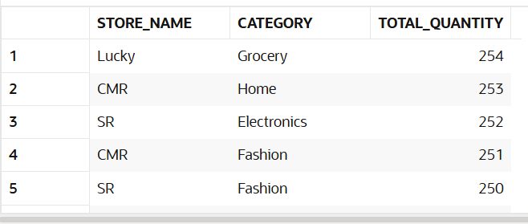
order by total_quantity desc;

-- 73. Find revenue generated by each customer in each store
select c.customer_name, st.store_name, sum(s.amount) as revenue
from sales s
join customers c on s.customer_id = c.customer_id
join stores st on s.store_id = st.store_id
group by c.customer_name, st.store_name
order by revenue desc;
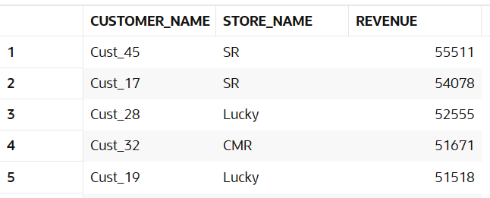

-- 74. Find quantity purchased by each customer for each product category
select c.customer_name, p.category, sum(s.quantity) as total_quantity
from sales s
join customers c on s.customer_id = c.customer_id
join products p on s.product_id = p.product_id
group by c.customer_name, p.category
order by total_quantity desc;
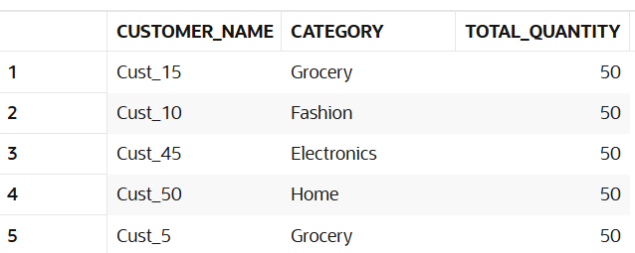

-- 75. Find revenue generated per day with store name
select s.sale_date, st.store_name, sum(s.amount) as revenue
from sales s
join stores st on s.store_id = st.store_id
group by s.sale_date, st.store_name
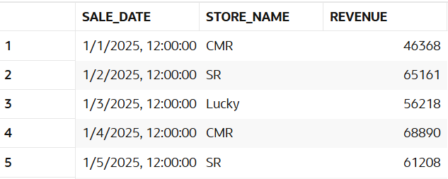
order by s.sale_date;

-- 76. Find total revenue generated by each product category in each store
select st.store_name, p.category, sum(s.amount) as revenue
from sales s
join stores st on s.store_id = st.store_id
join products p on s.product_id = p.product_id
group by st.store_name, p.category
order by revenue desc;

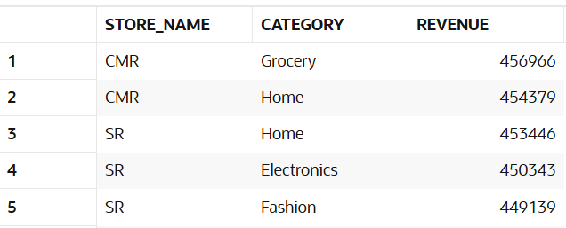

-- 77. Find total quantity sold by each product category in each store
select st.store_name, p.category, sum(s.quantity) as total_quantity
from sales s
join stores st on s.store_id = st.store_id
join products p on s.product_id = p.product_id
group by st.store_name, p.category
order by total_quantity desc;
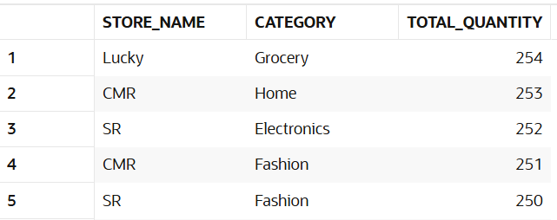

-- 78. Find number of transactions for each product category in each store
select st.store_name, p.category, count(s.sale_id) as transactions
from sales s
join stores st on s.store_id = st.store_id
join products p on s.product_id = p.product_id
group by st.store_name, p.category
order by transactions desc;

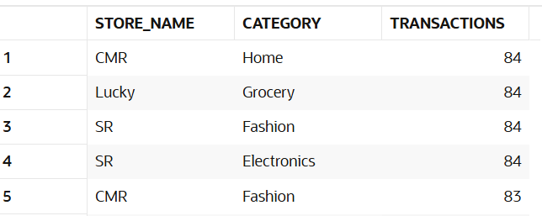

-- 79. Find total revenue generated by each customer in each product category
select c.customer_name, p.category, sum(s.amount) as revenue
from sales s
join customers c on s.customer_id = c.customer_id
join products p on s.product_id = p.product_id
group by c.customer_name, p.category
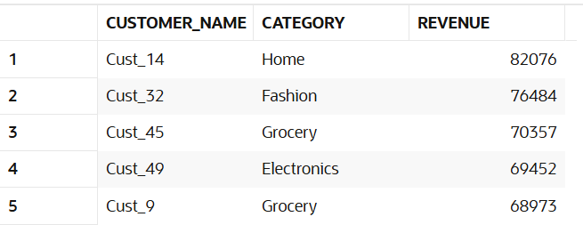
order by revenue desc;

-- 80. Find total quantity purchased by each customer in each store
select c.customer_name, st.store_name, sum(s.quantity) as total_quantity
from sales s
join customers c on s.customer_id = c.customer_id
join stores st on s.store_id = st.store_id
group by c.customer_name, st.store_name
order by total_quantity desc;
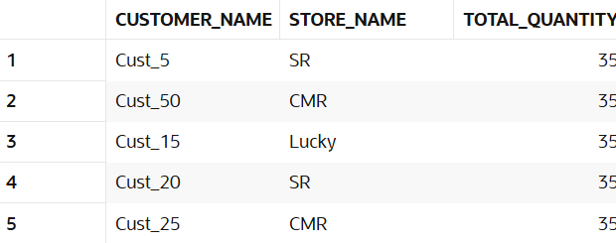

-- 81. Find number of purchases made by each customer in each store
select c.customer_name, st.store_name, count(s.sale_id) as purchases
from sales s
join customers c on s.customer_id = c.customer_id
join stores st on s.store_id = st.store_id
group by c.customer_name, st.store_name
order by purchases desc;
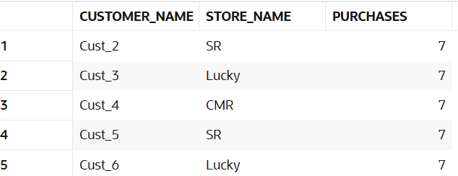

-- 82. Find average revenue per transaction by store
select st.store_name, avg(s.amount) as avg_revenue
from sales s
join stores st on s.store_id = st.store_id
group by st.store_name
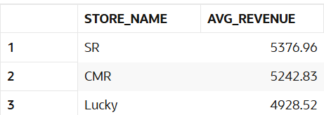
order by avg_revenue desc;

-- 83. Find average quantity sold per transaction by product category
select p.category, avg(s.quantity) as avg_quantity
from sales s
join products p on s.product_id = p.product_id
group by p.category
order by avg_quantity desc;
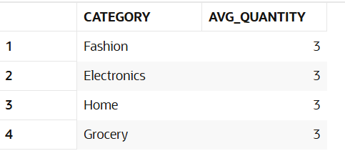

-- 84. Find maximum sale amount for each store
select st.store_name, max(s.amount) as max_sale
from sales s
join stores st on s.store_id = st.store_id
group by st.store_name
order by max_sale desc;
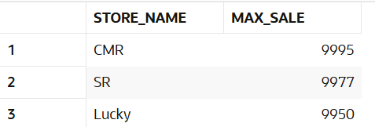

-- 85. Find minimum sale amount for each store
select st.store_name, min(s.amount) as min_sale
from sales s
join stores st on s.store_id = st.store_id
group by st.store_name
order by min_sale;
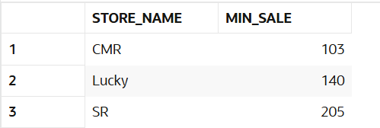

-- 86. Find maximum quantity sold for each product category
select p.category, max(s.quantity) as max_quantity
from sales s
join products p on s.product_id = p.product_id
group by p.category
order by max_quantity desc;
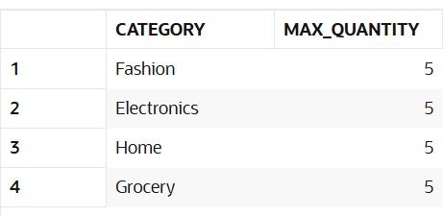

-- 87. Find minimum quantity sold for each product category
select p.category, min(s.quantity) as min_quantity
from sales s
join products p on s.product_id = p.product_id
group by p.category
order by min_quantity;
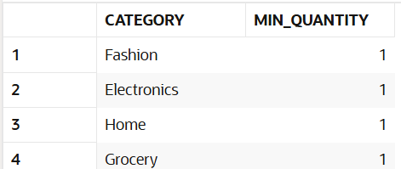

-- 88. Find total discount given by each store
select st.store_name, sum(s.discount) as total_discount
from sales s
join stores st on s.store_id = st.store_id
group by st.store_name
order by total_discount desc;
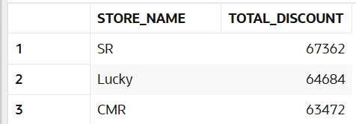

-- 89. Find total discount given for each product category
select p.category, sum(s.discount) as total_discount
from sales s
join products p on s.product_id = p.product_id
group by p.category
order by total_discount desc;
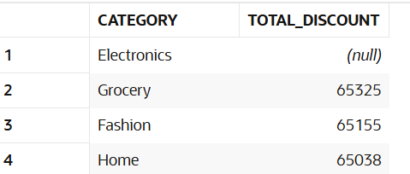

-- 90. Find total discount received by each customer
select c.customer_name, sum(s.discount) as total_discount
from sales s
join customers c on s.customer_id = c.customer_id
group by c.customer_name
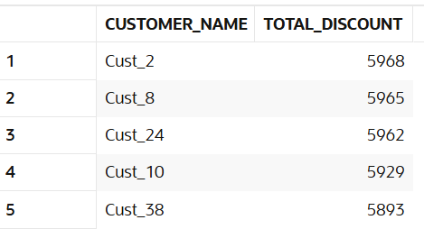
order by total_discount desc;

-- 91. Divide customers into 4 segments
select c.customer_name, sum(s.amount) as revenue,
ntile(4) over(order by sum(s.amount) desc) as customer_segment
from sales s
join customers c on s.customer_id = c.customer_id
group by c.customer_name;
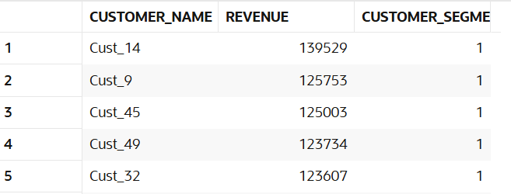

-- 92. Identify top 25% customers
select *
from (
select c.customer_name, sum(s.amount) as revenue,
ntile(4) over(order by sum(s.amount) desc) as segment
from sales s
join customers c on s.customer_id = c.customer_id
group by c.customer_name
) t
where segment = 1;
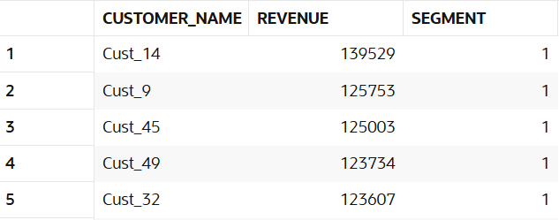

-- 93. Identify bottom 25% customers
select * from (
select c.customer_name, sum(s.amount) as revenue,
ntile(4) over(order by sum(s.amount) desc) as segment
from sales s
join customers c on s.customer_id = c.customer_id
group by c.customer_name
) t where segment = 4;
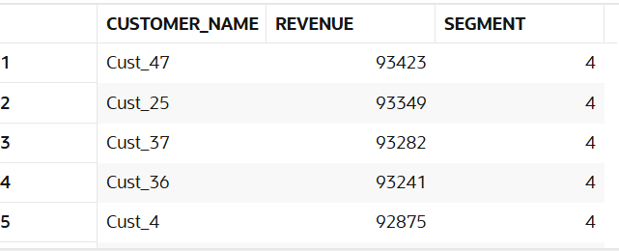

-- 94. Segment stores into 3 groups
select st.store_name, sum(s.amount) as revenue,
ntile(3) over(order by sum(s.amount) desc) as store_segment
from sales s
join stores st on s.store_id = st.store_id
group by st.store_name;
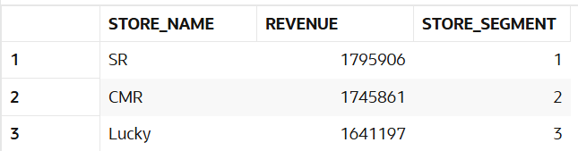

-- 95. Create quartiles based on revenue
select c.customer_name, sum(s.amount) as revenue,
ntile(4) over(order by sum(s.amount)) as revenue_quartile
from sales s
join customers c on s.customer_id = c.customer_id
group by c.customer_name;

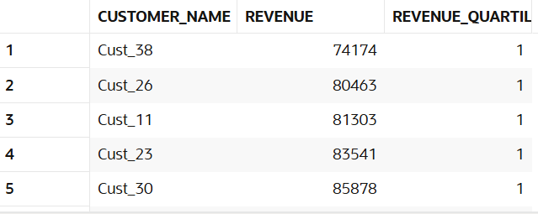

-- 96. Segment customers per store
select st.store_name, c.customer_name, sum(s.amount) as revenue,
ntile(4) over(partition by st.store_name order by sum(s.amount) desc) as store_customer_segment
from sales s
join customers c on s.customer_id = c.customer_id
join stores st on s.store_id = st.store_id
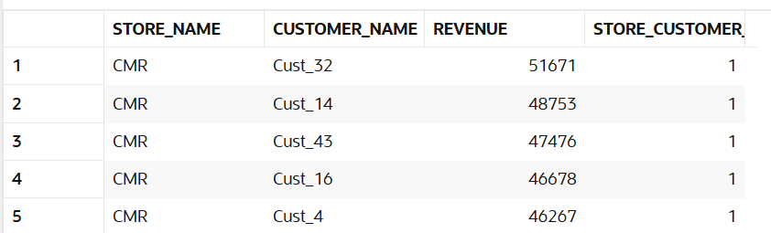
group by st.store_name, c.customer_name;

-- 97. Identify premium segment
select * from (
select c.customer_name, sum(s.amount) as revenue,
ntile(4) over(order by sum(s.amount) desc) as segment
from sales s
join customers c on s.customer_id = c.customer_id
group by c.customer_name
) t
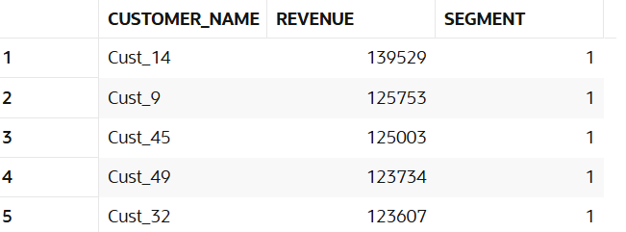
where segment = 1;

-- 98. Find mid-level customers
select * from (
select c.customer_name, sum(s.amount) as revenue,
ntile(4) over(order by sum(s.amount) desc) as segment
from sales s
join customers c on s.customer_id = c.customer_id
group by c.customer_name
) t
where segment in (2,3);
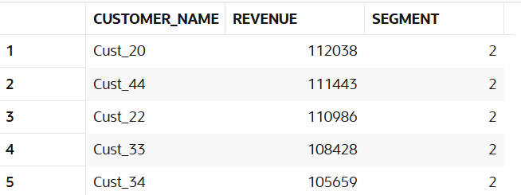

-- 99. Analyze bucket distribution
select segment, count(*) as customer_count
from (
select c.customer_name,
ntile(4) over(order by sum(s.amount) desc) as segment
from sales s
join customers c on s.customer_id = c.customer_id
group by c.customer_name
) t
group by segment
order by segment;
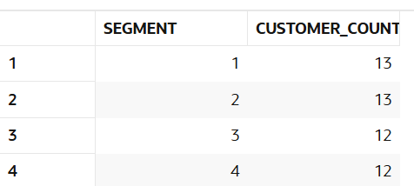

-- 100. Create marketing segments
select c.customer_name, sum(s.amount) as revenue,
case when ntile(4) over(order by sum(s.amount) desc) = 1 then 'premium'
when ntile(4) over(order by sum(s.amount) desc) = 2 then 'gold'
when ntile(4) over(order by sum(s.amount) desc) = 3 then 'silver'
else 'basic'
end as marketing_segment
from sales s
join customers c on s.customer_id = c.customer_id
group by c.customer_name;
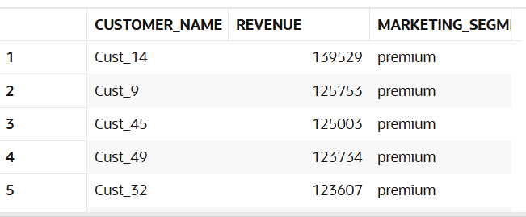

-- 101. Find highest sale
select distinct first_value(s.amount) over(order by s.amount desc) as highest_sale
from sales s;
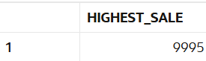

-- 102. Find lowest sale
select distinct last_value(s.amount) over(
order by s.amount desc
rows between unbounded preceding and unbounded following
) as lowest_sale
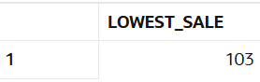
from sales s;

-- 103. Compare each sale with highest
select s.sale_id, s.amount,
first_value(s.amount) over(order by s.amount desc) as highest_sale,
s.amount - first_value(s.amount) over(order by s.amount desc) as difference_from_highest
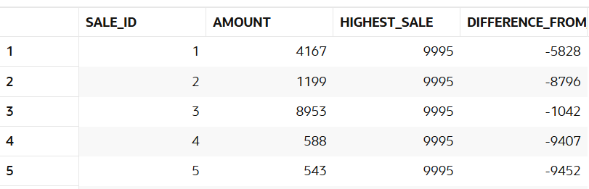
from sales s;

-- 104. Compare each sale with lowest
select s.sale_id, s.amount,
last_value(s.amount) over(
order by s.amount desc
rows between unbounded preceding and unbounded following
) as lowest_sale,
s.amount - last_value(s.amount) over(
order by s.amount desc
rows between unbounded preceding and unbounded following
) as difference_from_lowest
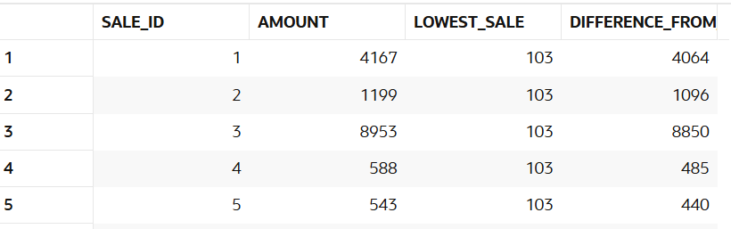
from sales s;

-- 105. Find highest sale per store
select distinct st.store_name,
first_value(s.amount) over(partition by st.store_name order by s.amount desc) as highest_store_sale
from sales s
join stores st on s.store_id = st.store_id;
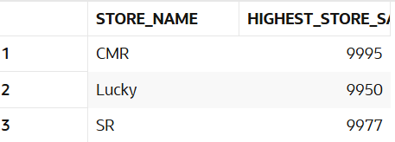

-- 106. Find lowest sale per store
select distinct st.store_name,
last_value(s.amount) over(
partition by st.store_name
order by s.amount desc
rows between unbounded preceding and unbounded following
) as lowest_store_sale
from sales s
join stores st on s.store_id = st.store_id;
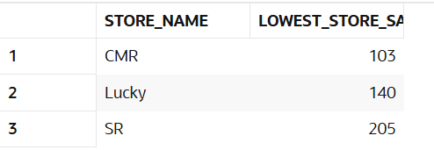

-- 107. Compare category performance
select distinct p.category,
first_value(s.amount) over(partition by p.category order by s.amount desc) as category_sale
from sales s
join products p on s.product_id = p.product_id;
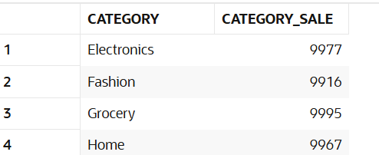

-- 108. Find best customer per store
select store_name, customer_name, revenue
from (
select st.store_name, c.customer_name, sum(s.amount) as revenue,
row_number() over(partition by st.store_name order by sum(s.amount) desc) as rn
from sales s
join customers c on s.customer_id = c.customer_id
join stores st on s.store_id = st.store_id
group by st.store_name, c.customer_name
) t
where rn = 1;
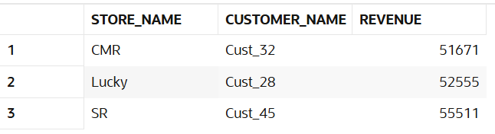

-- 109. Find worst performing category
select category, revenue from (
select p.category, sum(s.amount) as revenue,
row_number() over(order by sum(s.amount)) as rn
from sales s
join products p on s.product_id = p.product_id
group by p.category
) t
where rn = 1;
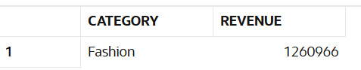

-- 110. Analyze gap between best and worst sale
select distinct first_value(s.amount) over(order by s.amount desc) as best_sale,
last_value(s.amount) over(order by s.amount desc
rows between unbounded preceding and unbounded following) as worst_sale,
first_value(s.amount) over(order by s.amount desc)
- last_value(s.amount) over(order by s.amount desc
rows between unbounded preceding and unbounded following) as gap
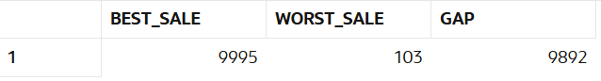
from sales s;

-- 111. Find daily sales
select s.sale_date, sum(s.amount) as revenue
from sales s
group by s.sale_date
order by s.sale_date;
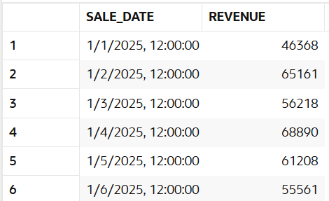

-- 112. Find monthly sales
SELECT TO_CHAR(s.sale_date, 'MM-YYYY') AS month,
SUM(s.amount) AS revenue
FROM sales s
GROUP BY TO_CHAR(s.sale_date, 'MM-YYYY')
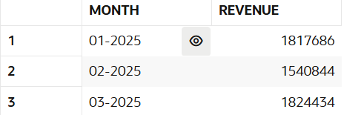
ORDER BY month;

-- 113. Find weekend sales
select sale_date,sum(amount) as Weekend_sales
from sales
where to_char(sale_date,'dy') in('sat','sun')
group by sale_date order by sale_date;

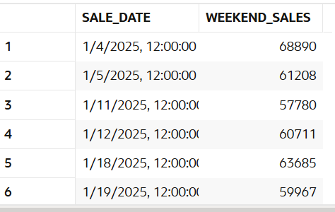

-- 114. Find first sale date
select min(s.sale_date) as first_sale_date
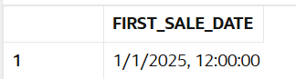
from sales s;

-- 115. Find last sale date
select max(s.sale_date) as last_sale_date
from sales s;
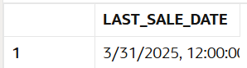

-- 116. Find sales in a specific month
select s.sale_date, sum(s.amount) as revenue
from sales s
where extract(month from s.sale_date) = 1
group by s.sale_date
order by s.sale_date;
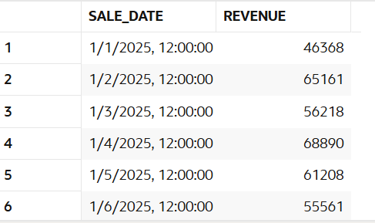

-- 117. Find sales growth month-wise
SELECT month,revenue,revenue - LAG(revenue) OVER (ORDER BY month) AS growth
FROM (SELECT
TO_CHAR(s.sale_date, 'YYYY-MM') AS month,
SUM(s.amount) AS revenue
FROM sales s
GROUP BY TO_CHAR(s.sale_date, 'YYYY-MM')
) t
order by month;
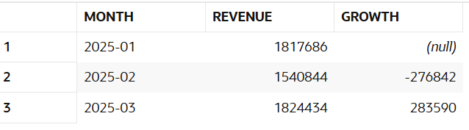

-- 118. Find inactive customers (30 days)
SELECT c.customer_name
FROM customers c
LEFT JOIN sales s
ON c.customer_id = s.customer_id
AND s.sale_date >= (SELECT MAX(sale_date) FROM sales) - 30
WHERE s.customer_id IS NULL;
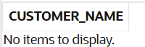

-- 119. Find repeat customers
select c.customer_name, count(s.sale_id) as purchases
from sales s
join customers c on s.customer_id = c.customer_id
group by c.customer_name
having count(s.sale_id) > 1
order by purchases desc;
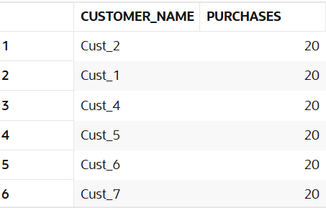

-- 120. Find sales trend
select s.sale_date, sum(s.amount) as revenue,
lag(sum(s.amount)) over(order by s.sale_date) as previous_day_revenue
from sales s
group by s.sale_date
order by s.sale_date;
